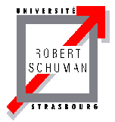 | 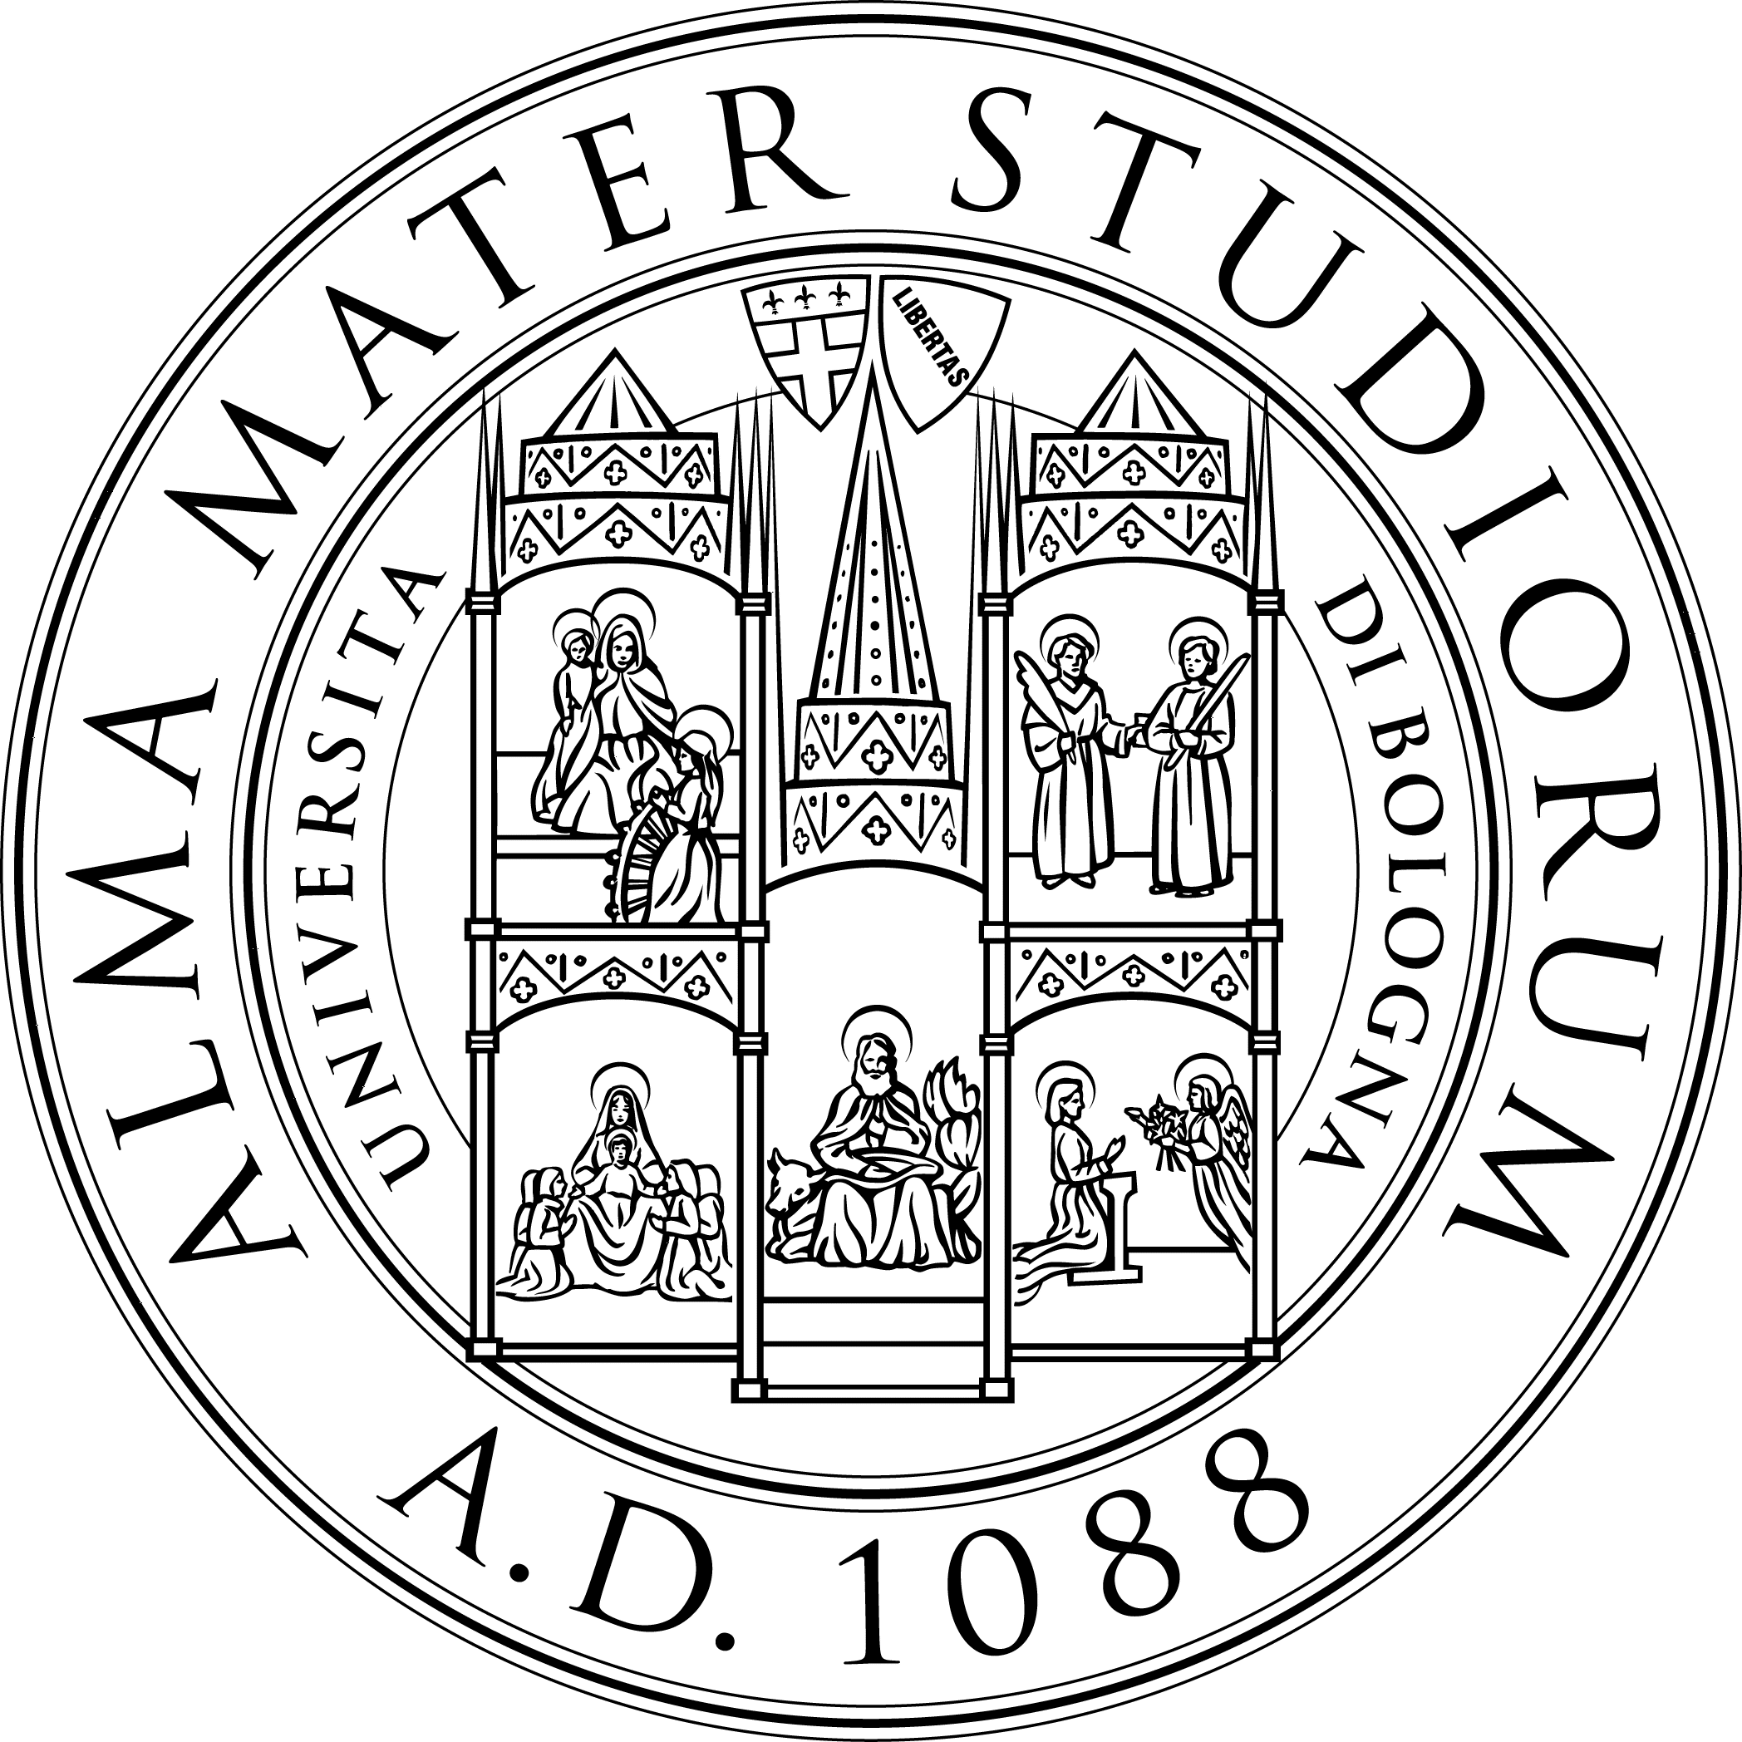 | 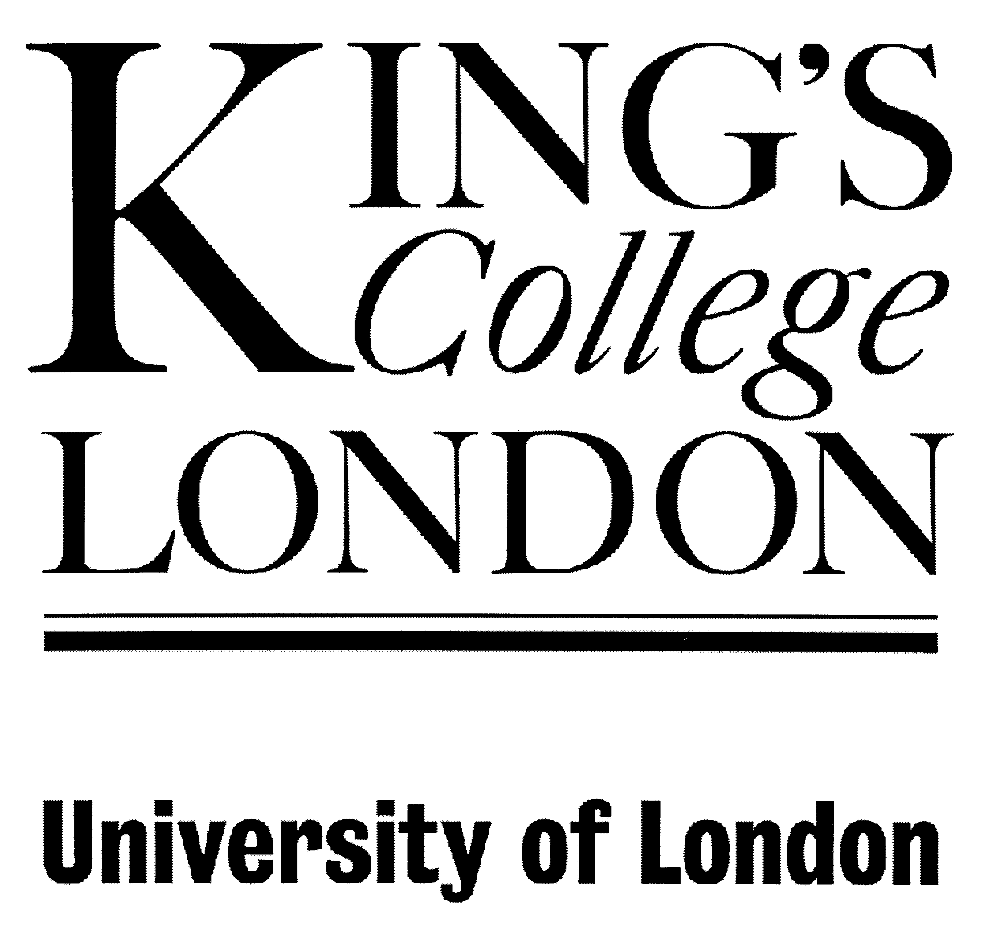

The protection of Fundamental Rights in Europe

Facoltà di Giurisprudenza - CIRDCE Università di Bologna
Faculté de Droit - Université Robert Schuman Strasbourg
Centre of European Law - King’s College, London

With the support of Fondazione Cassa dei Risparmi Forlì

and of the Jean Monnet Chair (EU Commission)
Course Languages: French/English
Students are required to have a good understanding of both languages

Draft Programme

Bertinoro, July 8th-13th 2007

Sunday July, 8th
Students Arrival: (afternoon) Welcome Reception

Monday July, 9th
9h.30-11h
Patrick WACHSMANN, Professor, University Robert Schuman of Strasbourg
Convention européenne des droits de l'homme : principes d'interprétation I
11h.30-13h
Patrick WACHSMANN, Professor, University Robert Schuman of Strasbourg
Convention européenne des droits de l'homme : principes d'interprétation II
15h.30–17h
Marco Balboni, Professor, University of Bologna / oppure

Les droits de l’homme et les conflits armés

Tuesday July, 10th
9h.30-11h.00
Giuseppe Cataldi, Professor, University Orientale of Napoli
European Court of Human rights and the Italian legal system
11h.30-13h
Giuseppe Cataldi, Professor, University Orientale of Napoli
International, European and National courts : The death penalty
15h.30–17h
Luca MEZZETTI, Professor, University of Bologna

Constitutional transition and human rights

Wednesday July, 11th
9h.30-11h
Satvinder JUSS, Professor, King’s College London
Article 3 Charter Fundamental Rights
11h.30-13h
Satvinder JUSS, Professor, King’s College London
Refugees and Human rights.
15h.30–17h
Vlad COSTANTINESCO, Professor, University Robert Schuman Strasbourg
La Communauté européenne devant la Cour européenne des droits de l'homme : de Matthews à Bosphorus

Thursday July, 12th
9h.30-11h
Piet Eeeckhout, Professor, King’s College London
Is the Charter of Fundamental Rights really non-binding?
11h.30-13h
Jean Paul JACQUÈ , Director in Legal Service, Council of European Union
Droits Fondamentaux, terrorisme international et Cour de Justice
15h.30–17h
Florence Benoît-Rohmer, Professor, University Robert Schuman of Strasbourg
La réforme de la Cour EDH

Friday July, 13th
9.30h.00-11h.00
Francis Jacobs, Professor and ex-Advocate General of the ECJ, King’s College London

Relationship between the ECJ and the European Court of Human Rights
11.30 – 13h.00
Fausto POCAR, Judge, International Criminal Tribunal for the former Yugoslavia
International Trends in the Protection of Human Rights
15h.30–16.30
Lucia ROSSI, Professor University of Bologna,
La CJCE : veritable juge constitutionnel de l’UE?

16.30 Avv. DOLCINI, Fondazione Cassa dei Risparmi di Forlì
Closing speech

Friday July, 13th17h.30-18h Final test (multiple choice)

Fees (including registration, course materials and boarding fees, including 5 nights in double bedrooms, breakfast, coffee breaks and lunch ):
PHD students: € 250; Undergraduate Students: €150; Robert Schuman and King’s College Students: €75.

A Certificate of attendance will be awarded to all participants. For the students of the Law Faculty of Bologna the course will award 3 credits.

Further details and Information:
Director: Prof. Lucia Serena Rossi lsr@cirdce.unibo.it
Tutor: Stephen Curzon : Stephenjames.curzon@gmail.com

